ETIOPATHOGENESIS AND MODERN LABORATORY DIAGNOSTICS OF CONNECTIVE TISSUE DISEASES
Connective tissue diseases (collagenoses) are immunopathological processes, characterized by systemic regeneration of connective tissue, as well as most other organs and tissues, progressive course and polymorphic clinical manifestations. Collagenoses include quite a large number of diseases, including rheumatoid arthritis (RA), systemic lupus erythematosus , scleroderma, dermatomyositis are more important. These diseases are united in a single group based on common pathomorphological signs (fibrinoid changes of collagen) and pathogenetic mechanisms (violation of immune homeostasis).
The common features combining the connective tissue diseases in a single group:
• Presence of common mechanisms in pathogenesis;
• Similarity of morphological change;
• Having chronic progress;
• Multisystemic damage.
RHEUMATOID ARTHRITIS
Rheumatoid arthritis (RA) is a chronic systemic inflammatory disease of the connective tissue mainly accompanied by erosive-destructive, progressive polyarthritis-type damage to the joints. The basis of the disease is inflammation of the joint tissues (synovial membrane, joint cartilage, joint capsule) of immune origin. It causes development of erosion, deformation and ankylosis of the articular surfaces of the bones.
The basis of extra-articular (skin, blood vessels, lungs, heart) damage is vasculitis developed as a result of immunocomplex type (type III) hypersensitivity reactions.
Etiology. Currently, it has been proven that genetic predisposition to arthritogenic factors plays a role in the etiology of the disease. Examples of arthritogenic factors include various viruses (Epstein-Barr virus, parvovirus B19) as well as other infectious factors (group B streptococci, mycoplasma). Hereditary predisposition is associated with the HLA-DRB27 gene. Thus, people carrying the HLA-DRB17 gene have a higher risk of developing the disease. It was also discovered that citrullinated proteins (enzymatic conversion of arginine to citrulline) produced in the body also play a role in the etiology of the disease.
Pathogenesis. Under the influence of etiological factors, the synovial membrane of the joint is damaged resulting in an immune response. Both humoral (IgG and IgM) and cellular (T lymphocyte) immune responses are involved in the pathogenesis of RA. It is believed that the process begins with the activation of CD4+ T-lymphocytes in genetically predisposed individuals. As a result, on the one hand, macrophages and various inflammatory mediators are activated; on the other hand, B-lymphocytes are activated and begin to synthesize immunoglobulins. At this time, IgM (autoantibodies) synthesized against both IgG and the Fc fragment of IgG are formed. These autoantibodies are called rheumatoid factor (RF) and combine with the Fc fragment of immunoglobulins from the IgG class to form immune complexes. In response, immune inflammation and deeper tissue damage occur, accompanied by stimulation of the immune response.
Among the pro-inflammatory mediators involved in the immunopathogenesis of rheumatoid arthritis, TNF-α is of particular importance. This cytokine induces procoagulants, weakens the anticoagulant properties of the endothelium and enhances the expression of adhesion molecules that ensure the transendothelial migration of leukocytes into the joint cavity. TNF-α causes pain, fever, cachexia, and promotes the development of new blood vessels playing an important role in the formation of rheumatoid pannus (the formation and growth of convex granulation connective tissue). Pannus is the main feature of rheumatoid arthritis, which gradually destroys the cartilage and epiphyses of the bones. , resulting in the formation of erosions. Destruction of cartilage leads to the development of fibrosis of the joint, and then bone ankylosis. Changes in periarticular tissues (joint capsule, tendon and muscles) also cause joint deformation. In addition to joint damage, RA also affects connective tissue, organs and systems.

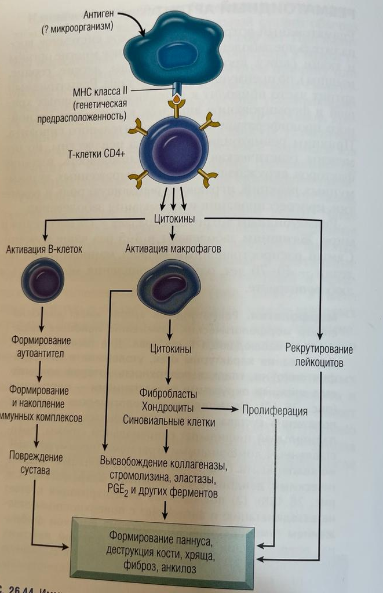
Formation of pannus, destruction of bone, cartilage, fibrosis, anchylosis
Release of collagenase, stromalisine, elastase, PGE₂ and other ferments
Proliferation
Fibroblasts
Chondrocytes
Synovial cells
Injure of joints
Formation and accumulation of the immunocomplexes
Leucocytes’
recruitment phenomenon
Formation of autoantibodies
Cytokines
Activation of macrophages
Activation of B-cells
Cytokines
T-cells CD4+
II class MNS
(genetic predisposition)
Antigen
(? microorganism)

Classification of rheumatoid arthritis
Forms
Rheumatoid arthritis
Polyarthritis
Oligoarthritis
Monoarthritis
RA with systemic symptoms
Main syndromes:
Felty's syndrome, Sjögren's syndrome, Still's disease in adults
Clinical-immunological characteristics (based on Rheumatoid factor)
Seropositive
Seronegative
Radiological stage
I - osteoporosis
II -osteoporosis + joint gap narrowing
III – osteoporosis + erosions
IV – osteoporosis + ankylosis
Functional feature
0 – fully stored
I – professional specialty is kept
II – professional quality is lost
IV – self-serving feature is lost

Clinic
RA is preceded by a prodromal period (anxiety, fatigue, depression, etc.) of several weeks or months.
Joint syndrome
- the disease begins with a gradual increase in pain and stiffness in small peripheral joints (wrist, phalanx comb, leg comb);
- joint damage is bilateral, symmetrical (inflammatory synovitis);
- pain in the joints is long-lasting, intensifies during physical work and decreases at night, it is sharper in the morning than in the evening;
- pain in the joints in the morning lasting more than 1 hour (cause: corticosteroid secretion increases more during the day);
- characteristic inflammatory changes in small peripheral joints: increased skin temperature, swelling, but the skin over the joints is not hyperemic;
- finally, the destruction process in the joints leads to ankylosis, deformation, contractures.
In the typical course of the disease, the damage is progressive over several months or years. At first, the limitation of movements is slight, then it becomes more noticeable. As a result, the deformation of the joints does not allow the patient to make even small movements.
b) Extra-articular manifestations of RA:
- constitutional: weakness, weakness, weight loss, subfebrile temperature
- rheumatoid nodules – deposition of immune complexes on the damaged joints or on the extensor surface area of ​​the ulna; the size of the nodules is from 2-3 mm to 4-5 cm, painless, mobile (located in the subcutaneous tissue) or stationary (located under the subcutaneous tissue). Rheumatoid nodules can very rarely be in the internal organs.
- cardiovascular system: pericarditis, "early atherosclerosis", motor arteritis (up to Raynaud's syndrome)
- lung: dry pleurisy, interstitial pulmonary fibrosis
- the ophthalmological symptom is keratoconjunctivitis, which develops against the background of secondary Sjögren's syndrome. As a result of the appearance of rheumatoid nodules in the sclera, scleromalacia can also develop.
- damage to the nervous system: compression neuropathy (compression of the nerve stump as a result of joint deformation), symmetrical neuropathy, multiple mononeuritis, cervical myelitis
- kidney: amyloidosis, renal tubular acidosis, interstitial nephritis (in most cases drug-induced)
- hematological: anemia, slight leukocytosis, thrombocytosis; Neutropenia in Felty syndrome
Felty's syndrome
Felty's syndrome is a symptom complex that usually develops in patients with severe seropositive rheumatoid arthritis and is manifested by severe neutropenia, splenomegaly, and severe joint damage.
Sjögren's syndrome
Sjögren's syndrome is an autoimmune damage to the exocrine glands (autoimmune epithelitis), which is more common in rheumatoid arthritis than in other systemic diseases of the connective tissue. The main clinical manifestations of Sjögren's syndrome are keratoconjunctivitis sicca (itching, burning, discomfort in the eyes, decreased visual acuity, "sand in the eyes" sensation) and xerostomia (dry mouth).
Still's disease in adults
Still's disease in adults is a disease characterized by febrile fever, arthritic and maculopapular rashes, elevated laboratory indicators of inflammation, and the absence of rheumatoid factor.
Laboratory diagnosis of RA.
A number of clinical and laboratory markers, especially blood tests, are used to assess the prognosis and treatment control of rheumatoid arthritis.
Blood test:
• Inflammatory markers increase of ESR, increase of CRP, increase of fibrinogen;
• Leukocytosis, thrombocytosis, neutropenia, thrombocytopenia during Felty's syndrome;
• Eosinophilia;
• Hypochromic anemia (anemia of chronic diseases);
Biochemical indicators:
• Hyperproteinemia or dysproteinemia (α2 globulin fraction↑)
• The activity of liver enzymes (ALT, AST) increases (usually, this correlates with the activity of RA and is often associated with the hepatotoxicity of anti-RA drugs).
Immunological markers:
• IgM rheumatoid factor (RF) (in the Vaaler-Rose reaction, the RF titer is considered high if it exceeds 1:10-1:20);
• IgG antibodies against cyclic citrulline-containing peptide (ACCP) (considered high at 7BV/ml or more).
Markers of inflammation are erythrocyte sedimentation rate (ESR), C-reactive protein (CRP) and fibrinogen. Elevated levels of ESR, CRP, or fibrinogen reflect disease activity. In addition, radiological studies have shown that CRP levels are associated with progressive joint destruction. Fibrinogen is not only an acute phase protein of inflammation, but also a blood clotting factor, and high concentration increases the risk of thrombosis and cardiovascular diseases.
Biochemical indicators investigated in rheumatoid arthritis include changes in liver enzymes (ALT, AST) and total amount of proteins in blood serum. Liver enzymes are also checked to assess hepatotoxicity, which is aimed at the determination of drugs and timely adjustment of their dosage.
Immunological indicators - antibodies against rheumatoid factor (RF) and cyclic citrulline-containing peptides (ACCP) - are used not only for the diagnosis of rheumatoid arthritis, but also to evaluate the activity and prognosis of the process. RF is an immunoglobulin of the IgM class directed against the Fc fragment of IgG immunoglobulins. RF is detected in 60-80% of patients with rheumatoid arthritis at the stage of full development of the disease. The sensitivity of this marker in the early stage of rheumatoid arthritis is about 30%. Thus, a negative RF result does not completely rule out rheumatoid arthritis. The RF level varies to some extent due to changes in disease activity, but may remain high even when clinical remission of the disease is achieved. The presence of RF is associated with progressive destruction of joints according to X-ray examination, regardless of the degree of disease activity. RF in blood serum is detected by the Waaler-Rose reaction or the latex test. (The RF titer in the Waaler-Rose reaction is considered high when it exceeds 1:10 to 1:20.) RF is not a specific marker for rheumatoid arthritis and can be found in many other autoimmune diseases such as systemic lupus erythematosus, sarcoidosis, and 5-7 in healthy people. A more specific marker of rheumatoid arthritis is antibodies against cyclic citrulline-containing peptide (ACCP). ACCP is a heterogeneous group of autoantibodies that interact with the amino acid citrulline of various proteins (fibrin, vimentin, type I and II collagen, histones, etc.). The specificity of this marker reaches 99%. Detection of ACCP in the blood is considered the gold standard in the diagnosis of RA (ACCP 7 BV/ml or more indicates a high risk of developing rheumatoid arthritis). Also, ACCP is more common than RF (ACCP – 70%, RF – 30%) in the early stages of rheumatoid arthritis. The concentration of ACCP can reflect the degree of disease activity. Detection of ACCP, like RF, is associated with joint destruction and is considered an unfavorable prognosis.
Synovial fluid analysis
In rheumatoid arthritis, the synovial fluid is usually cloudy, its viscosity is reduced, the protein level is elevated, and the glucose level is normal or slightly reduced. Rheumatoid arthritis is characterized by leukocytosis (more than 6x109/l) accompanied by an increase in the number of neutrophils (25-90%).

SYSTEMIC LUPUS ERYTHEMATOSUS

Systemic Lupus Erythematosus (SLE) is a chronic disease of young people (mainly women), which develops against the background of genetic defects of immune regulatory processes, which leads to the uncontrolled synthesis of antibodies against the body's own cells and their components, resulting in the development of autoimmune and immune complex chronic injuries. The basis of the disease is immune-inflammatory damage to connective tissue and microcirculatory vessels, skin, joints and internal organs.
A characteristic sign of the disease is the synthesis of autoantibodies. Some of them are directed against various nuclear and cytoplasmic components of the cell, while others are directed against surface antigens of blood cells.

Etiology.
The cause of SLE is unknown, but the presence of large amounts of autoantibodies against tissue components in these patients suggests that a lack of autotolerance plays a key role in the development of the disease. As with most autoimmune diseases, genetic, immunological, and environmental factors play a role in the pathogenesis of SLE.
Genetic factors. SLE is a genetically determined disease. The study of HLA associations confirms that MHC genes regulate the synthesis of certain autoantibodies. Specific alleles of the HLA-DQ locus are responsible for the synthesis of antibodies against double-stranded DNA, anti-Sm (against non-DNA nuclear components, i.e. nuclear ribonucleoprotein called Smith antigen) and antiphospholipid antibodies.
SLE patients inherit deficiency of the early components of the complement system - C2, C4 or C1q. Deficiency of the complement system impairs the removal of circulating immune complexes by the mononuclear phagocytic system, which can cause their deposition in tissues. C1q deficiency leads to impaired phagocytic clearance of apoptotic cells (Normally, many cells undergo apoptosis, but if they are not removed, their nuclear components can trigger an immune response).
Immunological factors. Numerous studies show the development of a number of changes in the immune system during SLE. This causes uncontrolled activation of autoreactive lymphocytes.
Environmental factors. The external environment also plays a role in the pathogenesis of SLE. Exposure to ultraviolet radiation can make the disease worse. Sex hormones also affect the development and manifestations of SLE. In reproductive age (from 17 to 55 years), the incidence of SLE in women is 10 times higher than in men. Aggravation of the disease is noted after childbirth and abortion. Medications such as hydralazine, procainamed, and D-penicillamine can cause the development of SLE.
Pathogenesis. There are different views on the explanation of the pathogenesis of SLE. Among them, the most widespread is the formation of an excessive amount of nuclear antigens from a large number of apoptotic cells, or the decrease in the rate of their clearance, and the simultaneous violation of the tolerance of T- and B-cells to these antigens. Rapid apoptosis of cells and decrease in clearance of nuclear antigens can be due to various external reasons (viruses, ultraviolet rays, etc.). The cause of the violation of immunological tolerance is related to hereditary predisposition, mainly the activity of MHC, complement system and other genes. Autoantigens stimulate tolerant lymphocytes and autoantibodies against these antigens are synthesized. The processed immune complexes further intensify the apoptosis and the process is repeated. Thus, a vicious cycle is created, which causes the process to become chronic. Regardless of the mechanism of formation, autoantibodies play an important role in tissue damage at the body level. Damage to internal organs is mostly caused by a type III hypersensitivity (immune complex) reaction.
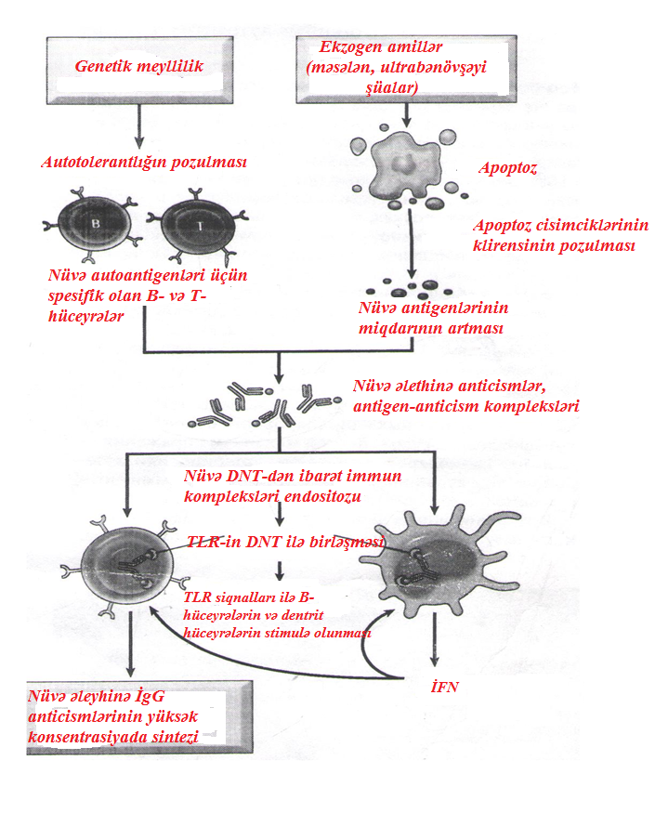
IFN
High concentration synthesis of antinuclear
IgG antibodies

Stimulation of B-cells and dendritic cells by TLR signals

Conjunction of TLR with DNA
Conjunction of TLR with DNA
Endocytosis of immune complexes containing nuclear DNA

Anti-nuclear antibodies, antigen-antibody complexes
Violation of clearance of the apoptosis particles
Increase of quantity
of the nuclear autoantigens
Violation of self-tolerance
B- and T-cells specific for the nuclear autoantigens

Apoptosis
Exogenic factors
(e.g. ultra-violet rays)

Genetic inclination

Clinic. SLE is a systemic disease with extremely variable clinical manifestations. It is more common in young women. The signs are as follows: exhibitions in the form of a butterfly on the face; photosensitization - increased sensitivity of the skin to the effects of sunlight, especially on surfaces exposed to sunlight, rashes characteristic of SLE appear; alopecia; fever; pain in one or more peripheral joints (but no deformity) - foot, knee, wrist, elbow and shoulder joints are damaged.
Most of the patients have kidney problems. Several forms of glomerulonephritis can develop, including mesangial, focal proliferative, diffuse proliferative, and membranous. Interstitial nephritis may also occur. Nephrotic syndrome causes proteinuria, edema of the legs, abdomen and orbital regions.
SLE often results in heart and lung complications. Pulmonary diseases such as pleurisy, acute pneumonitis, pulmonary hemorrhage, chronic interstitial lung disease, and pulmonary embolism, and cardiac complications such as pericarditis are common. Hematological disorders are manifested by hemolytic anemia, leukopenia, lymphopenia or thrombocytopenia.
CNS is damaged in 2/3 of patients. The pathological basis of neurological symptoms is acute vasculitis, which disrupts blood flow, causes stroke and bleeding, antineuron attacks on nerve cells, and an immune response associated with antiphospholipid antibodies that damage blood vessels and cause thrombi formation in the brain.
There is also a skin form of urticaria called discoid urticaria. In this form of SLE, there is no systemic effect. The cutaneous form of lupus erythematosus includes plaque-like lesions of the head, scalp, and neck.
Laboratory diagnosis of SLE.
General blood analysis
• ESR↑is elevated. However, this symptom correlates poorly with the degree of disease activity. An unexpected rise in ESR may be a sign of intercurrent infection.
• Anemia (including autoimmune hemylotic anemia; positive Coombs reaction)
• Leukopenia
• Thrombocytopenia
• Elevation of CRP is not characteristic, it increases in the presence of concomitant infection.
Changes in biochemical indicators are not specific and are determined by which internal organ is more damaged.
General analysis of urine: proteinuria, hematuria, leukocyturia are detected. Their prominence depends on the clinical morphological variant of lupus nephritis.
Immunological examinations
• Antinuclear antibodies IgG (ANA - antinuclear antibodies) are a heterogeneous group of autoantibodies directed against the components of their core. They can be divided into 4 categories: (1) anti-DNA antibodies; (2) antibodies against histones; (3) antibodies against non-histone proteins associated with RNA; (4) antibodies to nuclear antigens. The most commonly used method for the determination of ANA is the non-specific immunofluorescence assay, which detects antibodies that bind to a variety of nuclear antigens, including DNA, RNA, and proteins (these antibodies are generally known as ANA or antinuclear factor i.e. ANF). ANA is detected in 98% of patients with SLE. Therefore, a negative test result denies the diagnosis of SLE. These antibodies are not specific for SLE: they are also present in the blood during other diseases (other connective tissue diseases, autoimmune pancreatitis, primary biliary cirrhosis, some malignant tumors).
• Anti-dsDNA antibodies (anti-dsDNA) are autoantibodies directed against a person's own double-stranded DNA. They are a type of ANA. Anti-dsDNA is detected in approximately 70% of patients with SLE. Although the sensitivity of anti-dsDNA against SLE is low, their specificity reaches 100%. This high sensitivity means that a positive test result confirms the diagnosis of SLE.
• Smith's antigen (anti-Sm) - antibodies directed against non-DNA components of the nucleus (molecules containing RNA). Antibodies to SM are highly specific for SLE, but are identified in 10-30% of cases. They are a type of ANA.
• Antiphospholipid antibodies (IgG/IgM) are a heterogeneous group of autoantibodies directed against phospholipids and their associated proteins. This group includes antibodies against beta-2-glycoprotein, annexin V, phosphatidylprothrombin, etc. Antiphospholipid antibodies are detected in 40-50% of SLE patients. Antibodies against the phospholipid-β2-glycoprotein complex also bind to the cardiolipin antigen used in the serologic diagnosis of syphilis, so patients with SLE may have a positive Wasserman test for syphilis. These antibodies increase the risk of disorders of the blood clotting system, causing the formation of blood clots in the arteries and veins, which can lead to the development of strokes and heart attacks. Antiphospholipid antibodies also increase the risk of thrombocytopenia, repeated miscarriages (especially in the II and last III months of pregnancy), premature birth.
Other laboratory changes: LE (lupus erythematosus) cells (leukocytes that have phagocytosed nuclear materials), rheumatoid factor (RF) (in low titer) are determined in a number of patients, but their clinical significance is not so high.
Laboratory signs of SLE | Frequency of appearance in patients (%)
Anti-dsDNA | 80
Antinuclear antibodies (immunoglobulin G) | 95
Deposition of IgG, complement C3 and C4 components during skin biopsy | 75
Increase in the level of IgG in the blood serum | 65
Decreased levels of complement components C3 and C4 | 60
Cryoglobulinemia | 60
Antibodies against phospholipids | 30-40
RNA (antibodies against ribonucleoprotein-containing molecules) | 35
-Sm (Smith antigen) | 30
SS-A (Ro) | 30
SS-B (La) | 15
Low titer of rheumatoid factor | 30
Increase in ESR | 60
Proteinuria | 30
Leukopenia | 45
Pseudo Wasserman reaction | 10
Anticoagulant for lupus erythematosus | 10-20

SYSTEMIC SCLEROSIS (SS)
Systemic sclerosis (scleroderma) is a chronic disease characterized by inflammation of autoimmune origin, widespread damage to small blood vessels, progressive interstitial and perivascular fibrosis in the skin and many organs. Since the process of fibrosis is observed at the level of the whole organism, it is considered more appropriate to call this disease systemic sclerosis. Systemic sclerosis is most often observed in people aged 50-60. It is more common in women than in men (3:1). During the disease, the most damaged organ is the skin, at the same time, the gastrointestinal tract, kidneys, heart, muscles and lungs are also involved in the pathological process. The cause of death in this disease is usually the development of kidney, heart, lung failure or malabsorption syndrome.
Etiology and pathogenesis
Although the etiology of systemic sclerosis is not exactly known, the role of viral infection is not excluded in the background of hereditary and genetic predisposition. The autoimmune reaction that develops during the disease, the damage of blood vessels and the accumulation of excess collagen are the main factors that cause tissue damage.
Autoimmune reaction. Antigen-responsive CD4+ T cells are thought to accumulate in the skin. These cells synthesize various cytokines, including TGF-β and IL-13, factors that increase inflammatory cells, collagen synthesis, and fibroblast proliferation. Other cytokines cause the development of chronic inflammation by ensuring the migration of leukocytes.
Vascular damage. Damage to microvessels is observed at the early stage of the development of systemic sclerosis. The intima of the finger arteries proliferates (in 100% of cases), the capillaries expand, their permeability increases, and they also undergo destruction, especially at the initial stage, the capillaries of the nail layer are deformed. Also, damage to the endothelium (increase in the level of Willebrand factor) and activation of platelets (the increase in the number of circulating platelet aggregates) is noted. The development of vascular damage can be the result of type I or chronic inflammation (due to the release of inflammatory mediators). Repetitive injury results in platelet aggregation, which leads to the release of platelet and endothelial factors (eg, PDGF, TGF-β) that cause perivascular fibrosis. Activated or damaged endothelial cells themselves synthesize PDGF and chemotaxisamyls for fibroblasts. Abnormalities in vascular muscle cells, especially increased expression of adrenergic receptors, are observed. Narrowing of the microvascular network leads to ischemic damage and scarring.
Accumulation of excess collagen. The progressive fibrosis characteristic of the disease is the culmination of a variety of disorders, primarily the effects of fibrogenic cytokines, fibroblast hyperreactivity, and scar tissue that develops after ischemic vascular injury.
Inductor
(an exogenic factor)
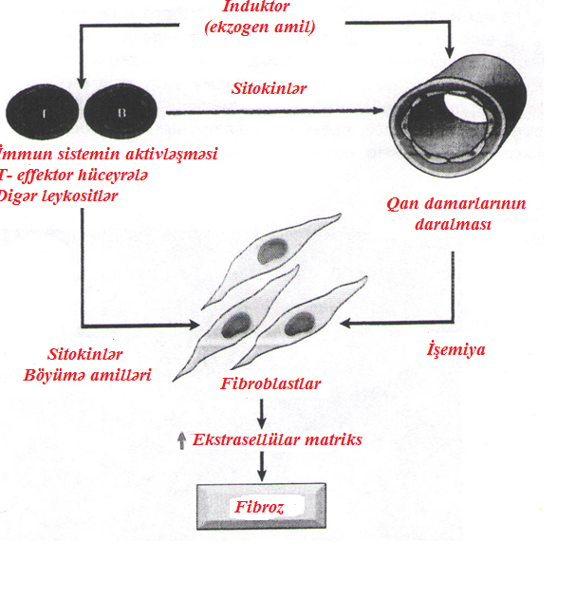
Fibrosis
Extracellular matrix
Fibroblasts
Cytokines
Factors of increase
Ischemia
Cytokines
Narrowing of
blood vessels
Activation of the immune system
T-effector cells
Other leucocytes

Clinical signs. Due to many of its symptoms, systemic sclerosis is similar to rheumatoid arthritis, but the difference is the sharp appearance of changes in the skin, especially thickening of the skin. Two main clinical forms of systemic sclerosis are distinguished: diffuse scleroderma and local scleroderma. Diffuse scleroderma is characterized by extensive skin damage from the beginning, rapid progression and early spread of the process to internal organs. Raynaud's syndrome is manifested by episodic narrowing of the arteries and arterioles of the extremities, which is found in almost all patients, and in 70% of cases it appears before other symptoms. Dysphagia and hypokinesia caused by esophageal fibrosis are observed in more than 50% of patients. Eventually, collapse of the esophageal wall leads to atony and dilation of the lower esophagus. Abdominal pain, intestinal obstruction or malabsorption syndrome accompanied by weight loss and anemia indicate damage to the small intestine. Difficulty breathing due to pulmonary fibrosis can lead to right-sided heart dysfunction, and myocardial fibrosis can lead to either arrhythmias or heart failure. Most patients have mild proteinuria, but rarely it is massive enough to cause nephrotic syndrome. The most dangerous manifestation is malignant hypertension, which leads to the development of kidney failure and death.
In localized scleroderma, the skin of the fingers, shoulder, and face is affected, but the internal organs are affected late, and therefore the clinical course is relatively benign. Patients with local scleroderma often develop CREST syndrome (calcinosis – deposition of calcium in the subcutaneous tissue; Raynaud's syndrome – characterized by reversible vasospasm of the arteries feeding the fingers; motor dysfunction of the esophagus, sclerodactyly, telangiectasia).
In general, these patients live longer than patients with systemic sclerosis, which is initially accompanied by diffuse damage to internal organs.
Laboratory diagnostics in systemic scleroderma.
Inflammatory markers: increase of CRP, increase of ESR, increase of level of fibrinogen;
Dysproteinemia accompanied by an increase in the level of α2 and γ-globulins.
Hypochromic anemia develops as a result of chronic inflammation. Gastrointestinal bleeding can lead to the development of anemia with iron deficiency, overgrowth of bacteria during atony of the small intestine i.e. folic acid deficiency and vitamin B12 deficiency. Microangiopathic hemolytic anemia usually develops during kidney damage and is associated with deposition of fibrin in renal arterioles. In about half of patients, hypergammaglobulinemia is detected against the background of increased IgG levels. A low titer of rheumatoid factor is determined in 25% of patients with systemic scleroderma. In 95% of patients, serum antinuclear antibodies are detected by immunofluorescence using human HEp-2 laryngeal cancer cell culture. Specific antinuclear antibodies for systemic sclerosis include:
• Antibodies IgG against Scl-70 antigen (antibodies against DNA-topoisomerase 1);
• antibodies against centromeres.
ANA against DNA-topoisomerase 1 (anti-Scl 70) has high specificity. ANA is found in 30-70% of patients with diffuse scleroderma. Patients with these antibodies have an increased risk of developing pulmonary fibrosis and peripheral vascular pathologies. Anticentromeric antibodies are detected in 90% of patients with a tendency to develop CREST syndrome or local scleroderma. Only rare in some cases, both types of ANA are detected in the same patient. Some of these antibodies can stimulate the development of fibrosis. Antibodies to nucleolars, including RNA polymerases I, II, and III, are also detected in 20-30% of patients. Antibodies against RNA polymerases I, II and III are most often detected in patients with diffuse systemic scleroderma and kidney, heart damage. Antibodies against U3-ribonucleoprotein (fibrillarin) are highly specific for systemic scleroderma (occurring in 20% of patients), skeletal muscle and intestinal damage, and are found in patients with pulmonary hypertension. Antibodies to RO/SS-A and La/SS-B antigens may be present in the serum of patients with a cross syndrome that combines features of systemic scleroderma and Sjögren's syndrome.

Table 1. Autoantibodies detected during systemic scleroderma
Autoantibodies | Disease form
Antibodies against Scl-70 antigen | Diffuse
Antibodies against centromeres | Local (GREST syndrome)
Antibodies against RNA polymerases I, II and III | Diffuse
Antibodies against Th-ribonucleoprotein | Local
Antibodies against U3-ribonucleoprotein | Diffuse

